# **32. IPv6 : PART 2**

## **IPv6 Address Configuration (EUI-64)**

* **EUI** stands for **Extended Unique Identifier**.
* **(Modified) EUI-64** is a method of converting a **MAC address (48-bits)** into a **64-bit INTERFACE identifier**.
* This INTERFACE identifier can then become the **“HOST portion”** of a **/64 IPv6 ADDRESS**.

### **EUI-64 Practice:**

782B CBAC 0867 >>> 782B CB || AC 0867

782B CBFF FEAC 0867

8 is the 7th bit so 1000 inverted becomes 1010 = A in hex

so the EUI-64 Interface Identifier is : 7A2B CBFF FEAC 0867

## **Configuring IPv6 Addresses with EUI-64**

* The **“2001:DB8…” Address** has **“E” changed to “C”**.
* This is the **7th bit getting flipped** (1110 to 1100 = 12 = hex ‘C’).

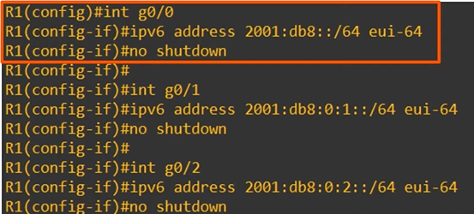

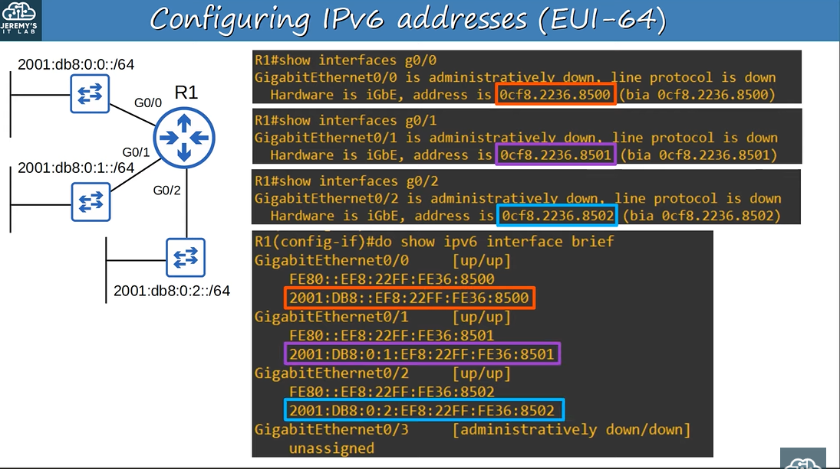

## **Why Invert the 7th Bit?**

### **MAC Addresses Can Be Divided Into Two Types:**

1. **UAA (Universally Administered Address)**
   * Uniquely assigned to the device by the manufacturer.
2. **LAA (Locally Administered Address)**
   * Manually assigned by an Admin (with the mac-address command on the INTERFACE) or protocol.
   * Doesn’t have to be globally unique.

### **Identifying UAA or LAA by the 7th Bit (U/L Bit - Universal/Local Bit):**

* **U/L bit set to 0** → UAA
* **U/L bit set to 1** → LAA

### **In the Context of IPv6 Addresses/EUI-64:**

* **U/L bit set to 0** → The MAC address the EUI-64 INTERFACE ID was made from was an **LAA**.
* **U/L bit set to 1** → The MAC address the EUI-64 INTERFACE ID was made from was a **UAA**.

# **IPv6 Address Types**

## **1) Global Unicast Addresses**

* **Global Unicast IPv6 ADDRESSES** are **PUBLIC ADDRESSES** that can be used over the **Internet**.
* Must **register** to use them.
* They are **public addresses** and must be **globally unique**.

💡 Originally defined as the **2000::/3** block (2000:: to 3FFF:FFFF:FFFF:FFFF:FFFF:FFFF:FFFF:FFFF).

* Now defined as **all addresses not reserved for other purposes**.

### **Structure of a Global Unicast Address:**

1. **Global Routing Prefix (48 bit assigned by ISP)**
2. **Subnet ID (16 bit used by enterprise)**
3. **Interface Identifier (host portion of address)**

## **2) Unique Local Addresses**

* **Unique Local IPv6 Addresses** are **PRIVATE ADDRESSES** that cannot be used over the **Internet**.
* **Do not** need to be registered.
* Can be used freely within **internal networks**.
* Do **not** need to be globally unique (*).
* **Cannot** be routed over the **Internet**.

💡 Uses the address block **FC00::/7** (FC00:: to FDFF:FFFF:FFFF:FFFF:FFFF:FFFF:FFFF:FFFF).

* A later update required the **8th bit to be set to 1**, so the **first two digits must be FD**.
* (*) **The Global ID should be unique** to prevent address overlap when companies **merge**. (40 bits after FD)

## **3) Link-Local Addresses**

* **Link-Local IPv6 Addresses** are **automatically generated** on **IPv6-enabled interfaces**.

Use command:  
 R1(config-if)# ipv6 enable

* to enable IPv6 on an interface.

💡 Uses the address block **FE80::/10** (FE80:: to FEBF:FFFF:FFFF:FFFF:FFFF:FFFF:FFFF:FFFF).

* **Standard states** that the **54-bits after FE80/10** should be **all 0’s**.
* **Link-local means** these addresses are used **within a single link (subnet)**.
* **Routers will not route packets** with a link-local destination IPv6 address.

### **Common Uses:**

* **Routing protocol peerings** (e.g., OSPFv3 neighbor adjacencies).
* **Next-hop address for static routes**.
* **Neighbor Discovery Protocol (NDP)** (IPv6’s replacement for ARP).

## **4) Multicast Addresses**

### **Address Types:**

* **Unicast** → One-to-One
* **Broadcast** (IPv4) → One-to-All
* **Multicast** → One-to-Many (devices in the same multicast group).

💡 Uses the range **FF00::/8** (FF00:: to FFFF:FFFF:FFFF:FFFF:FFFF:FFFF:FFFF:FFFF).

* **IPv6 does not use broadcast** (no "broadcast address").
* **Multicast addresses have scopes** that define **how far packets should be forwarded**.

### **IPv6 Multicast Scope Types:**

* **Interface-Local (FF01)** → Packet doesn’t leave the local device.
* **Link-Local (FF02)** → Packet remains in the local subnet.
* **Site-Local (FF05)** → Packet can be forwarded but should stay within a physical location.
* **Organization-Local (FF08)** → Can span an entire company/organization.
* **Global (FF0E)** → No boundaries; may be routed over the Internet.

## **5) Anycast Addresses**

* **Anycast** is a **new feature** in IPv6.
* **One-to-One-of-Many**: Multiple routers have the **same IPv6 address**.
* **Hosts send packets** to that address, and the routers forward it to the **nearest** router with that address (based on routing metrics).
* **No specific address range** for Anycast.

💡 Example Configuration:

R1(config-if)# ipv6 address 2000:db8:1:1::99/128 anycast

## **6) Other IPv6 Addresses**

### **Unspecified Address (::)**

* Used when a device **doesn’t know its IPv6 address yet**.
* **IPv6 default route:** ::/0.
* **IPv4 equivalent:** 0.0.0.0.

### **Loopback Address (::1)**

* Used to test the **protocol stack** on the **local device**.
* Packets **sent to ::1 never leave the device**.
* **IPv4 equivalent:** 127.0.0.1.